# SQL vs NoSQL

NoSQL (Not only SQL)

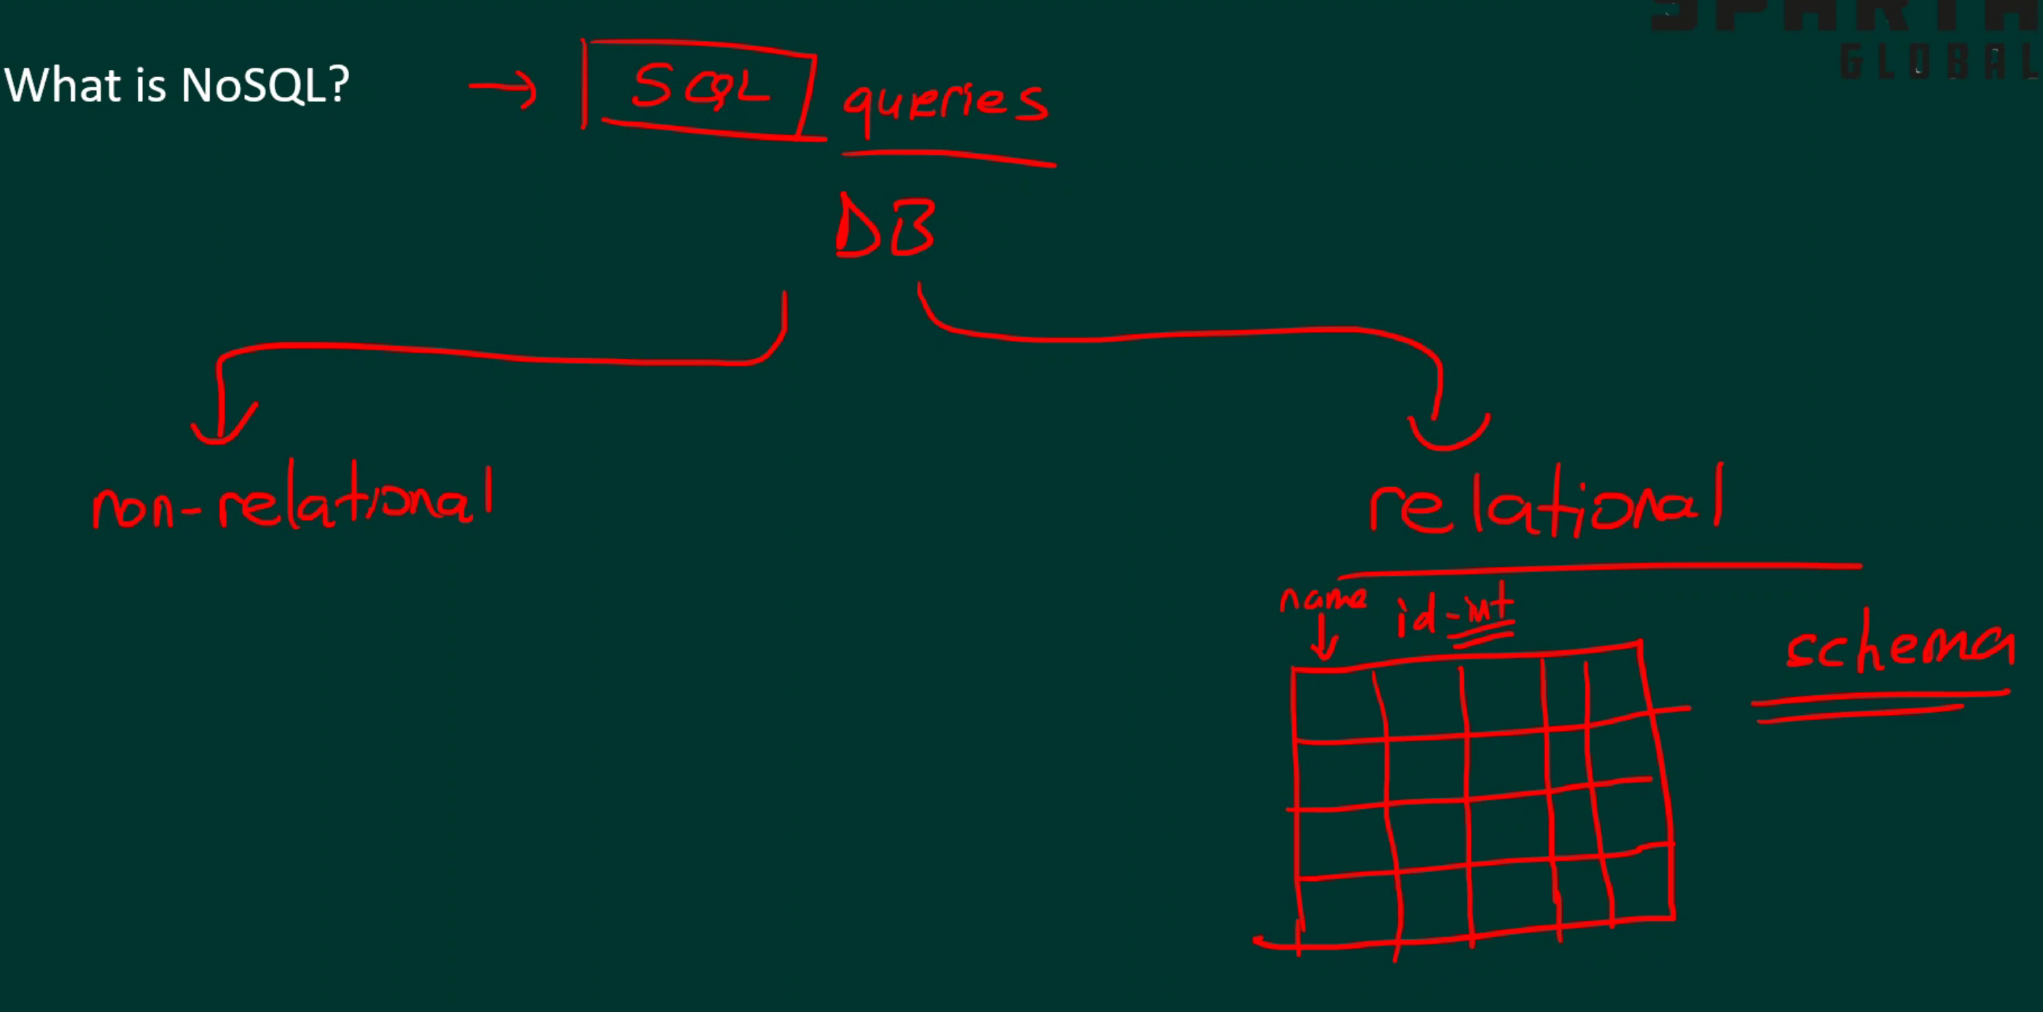

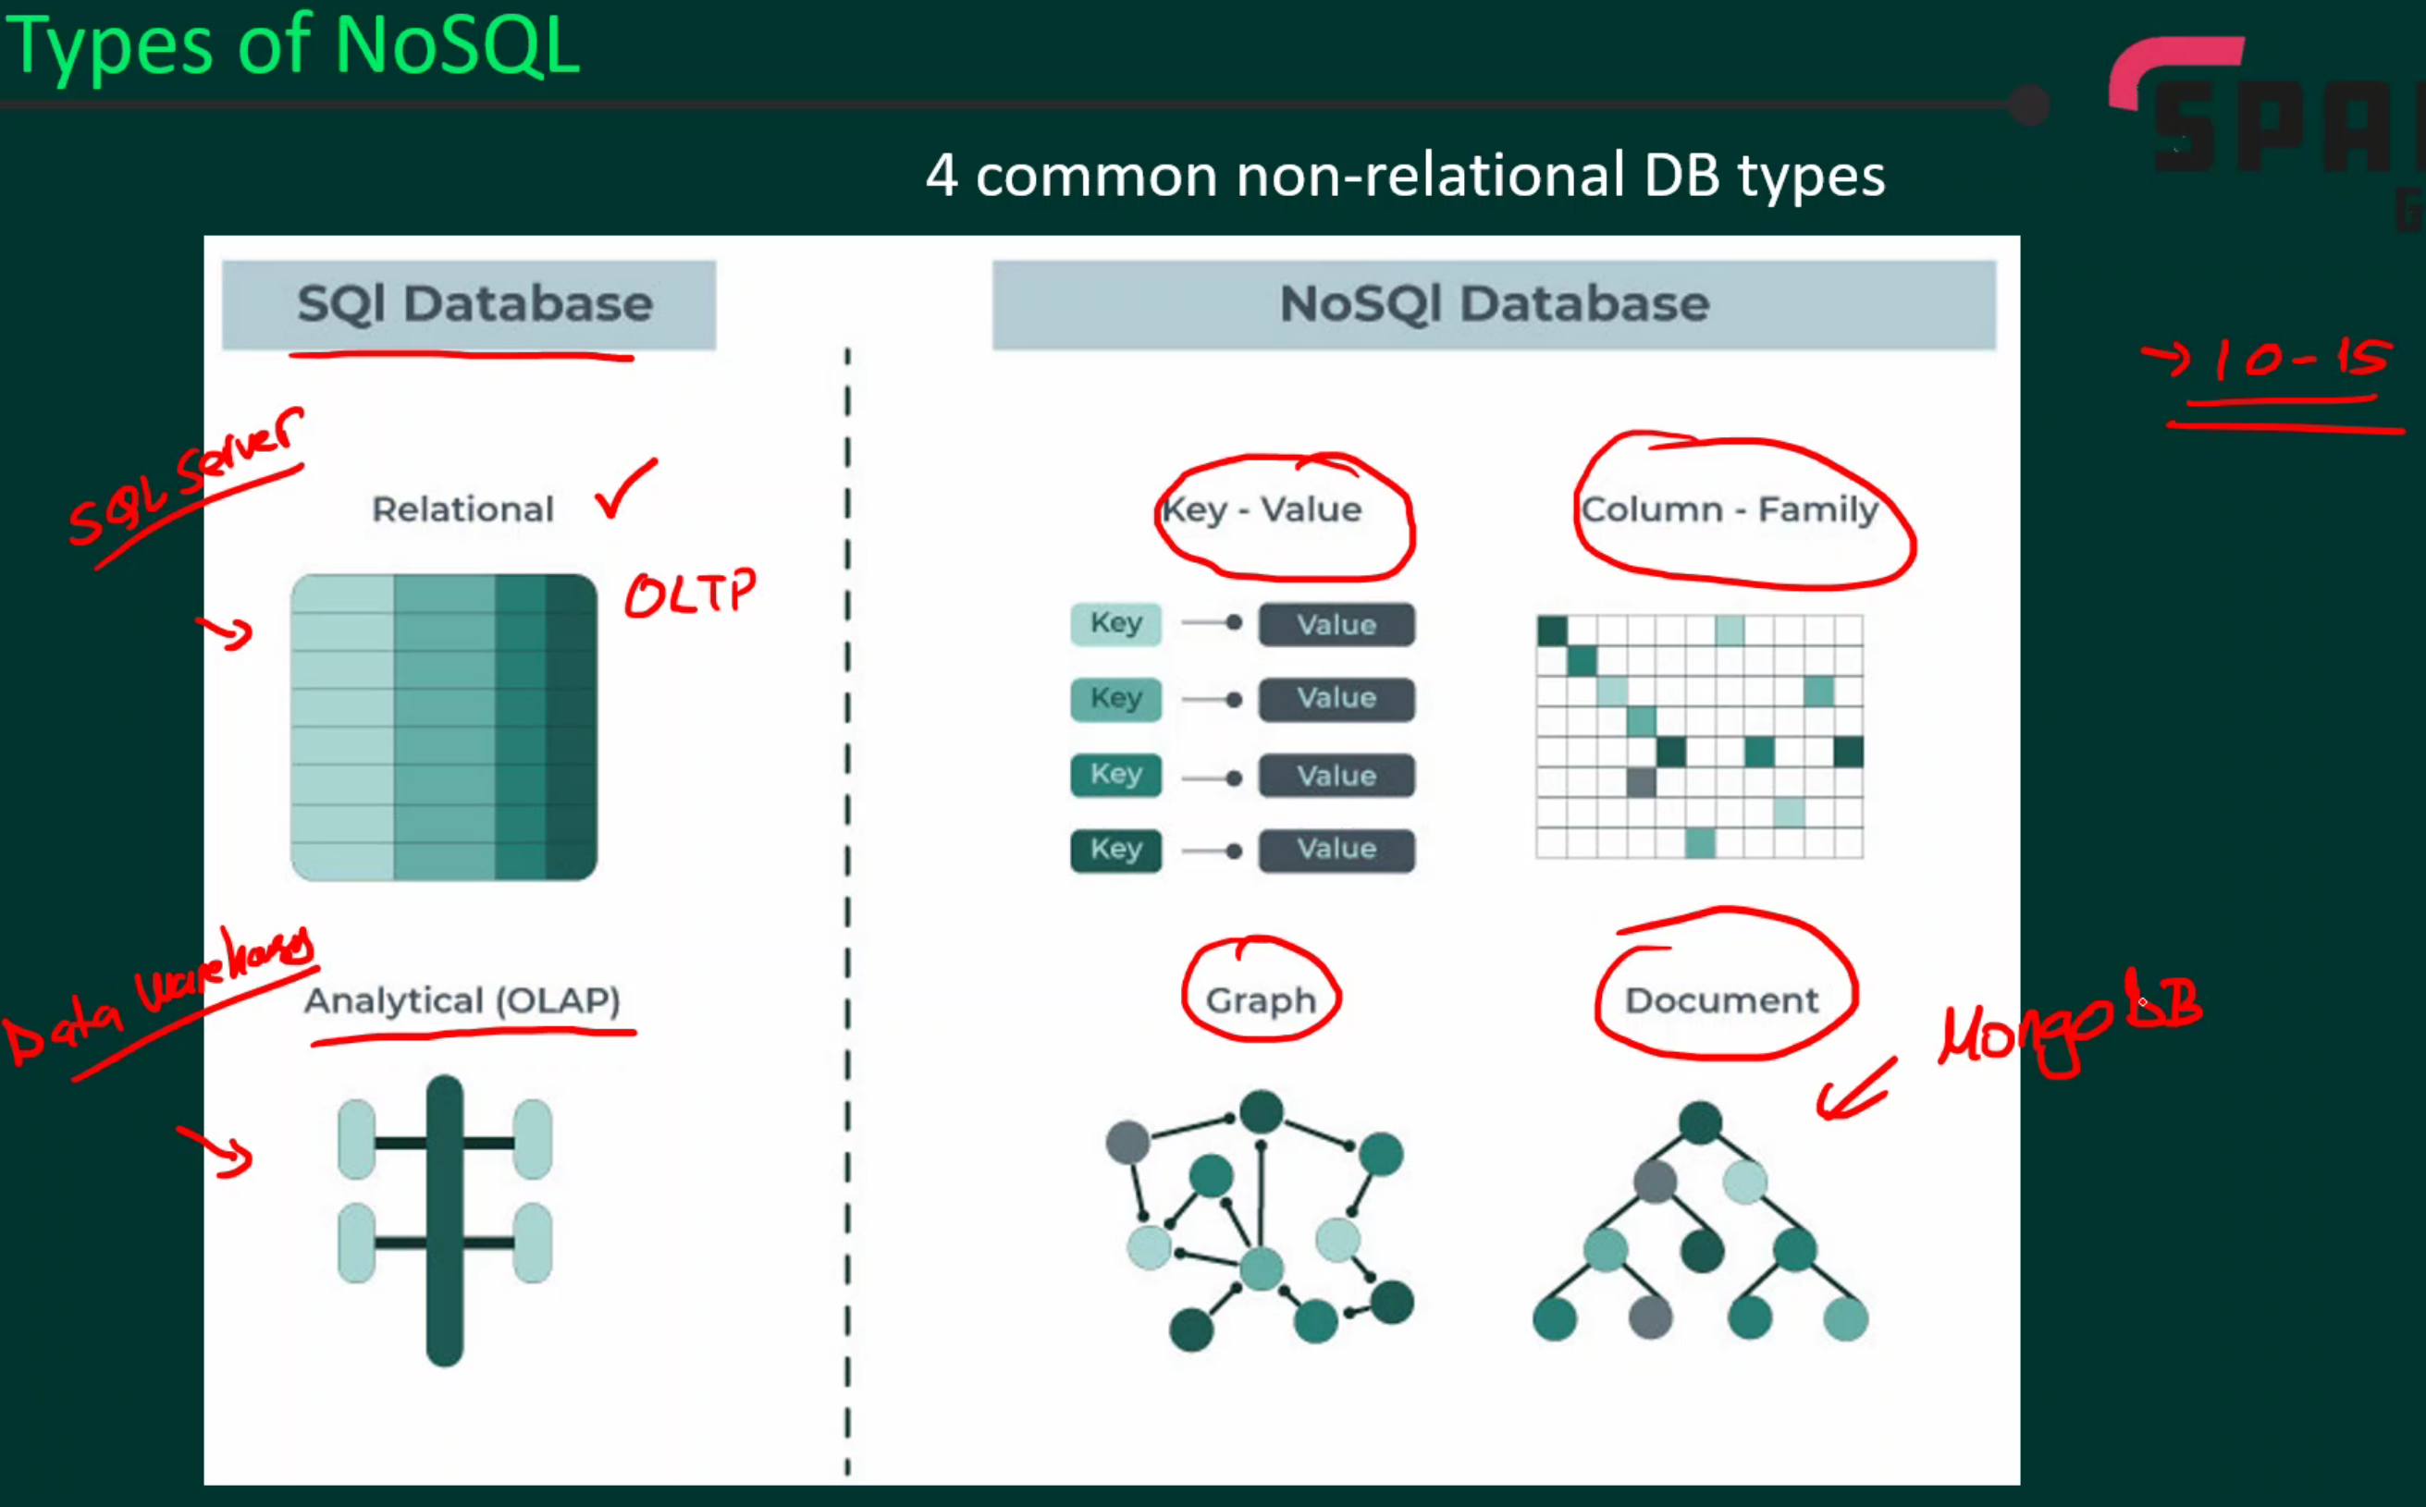

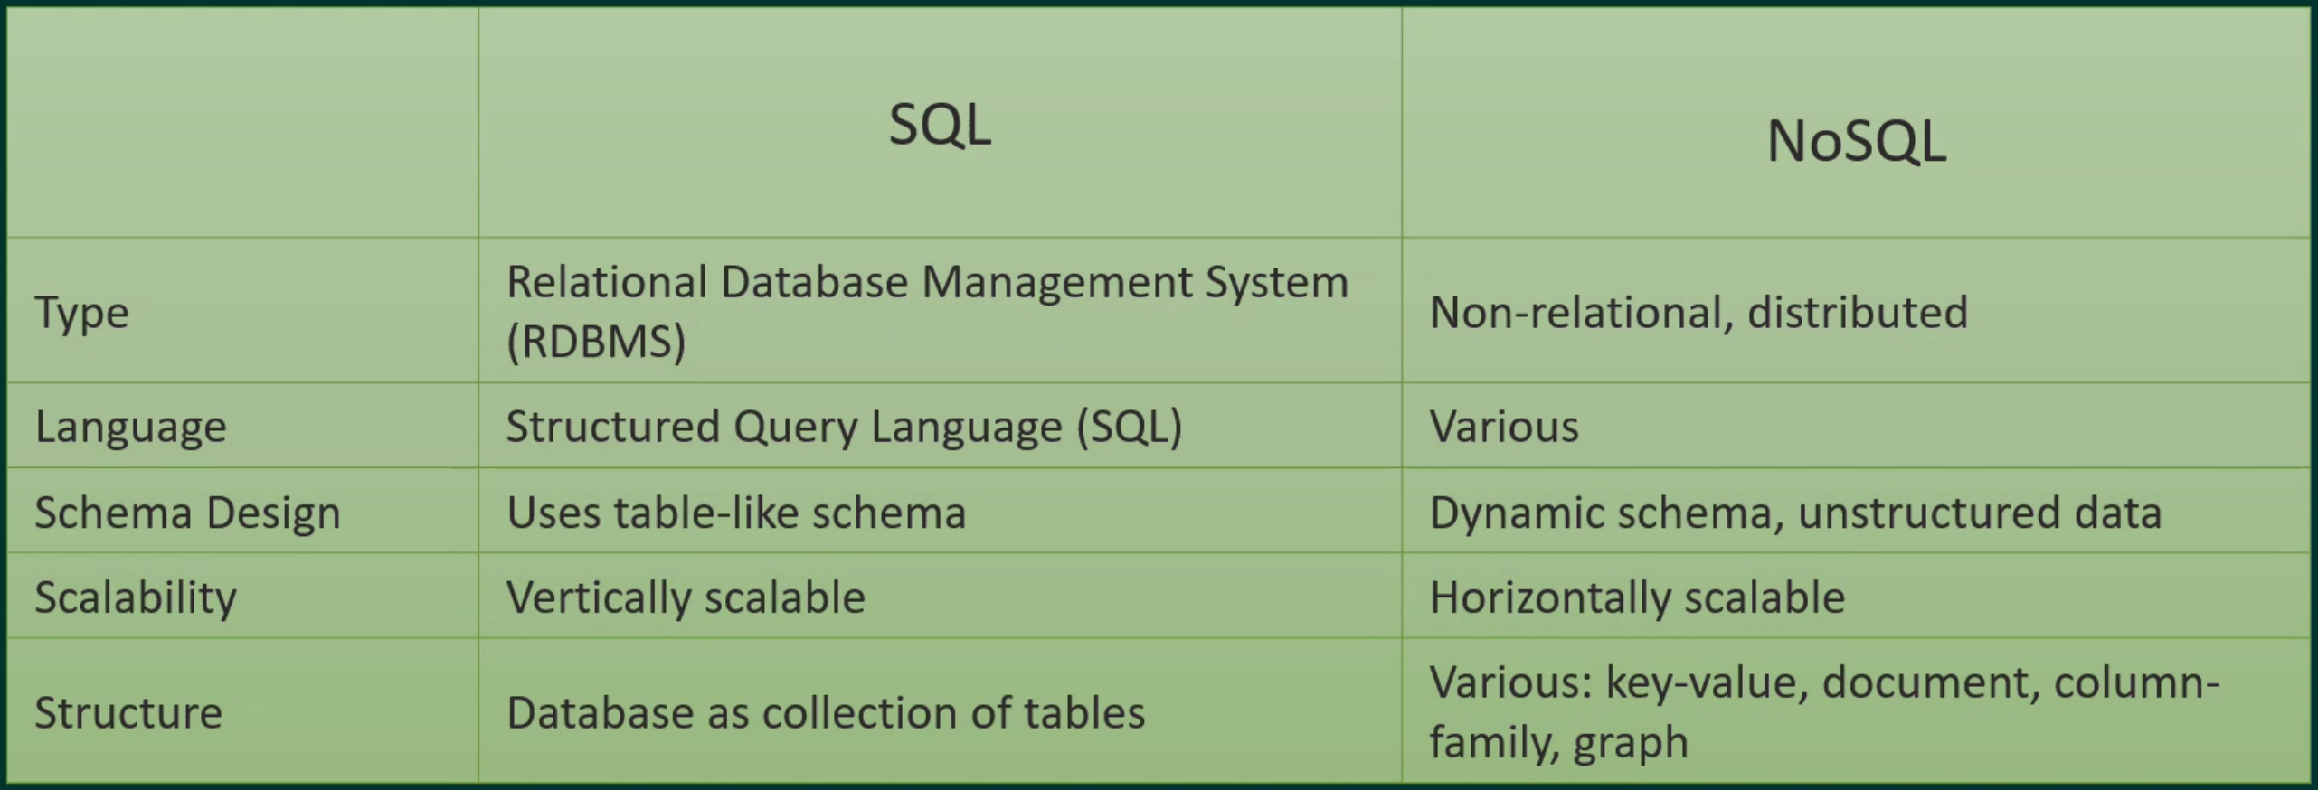

The popularity of NoSQL has been driven by the following reasons:

The pace of development with NoSQL databases can be much faster than with a SQL database

The structure of many different forms of data is more easily handled and evolved with a NoSQL database

The amount of data in many applications cannot be served affordably by a SQL database

The scale of traffic and need for zero downtime cannot be handled by SQL

New application paradigms can be more easily supported

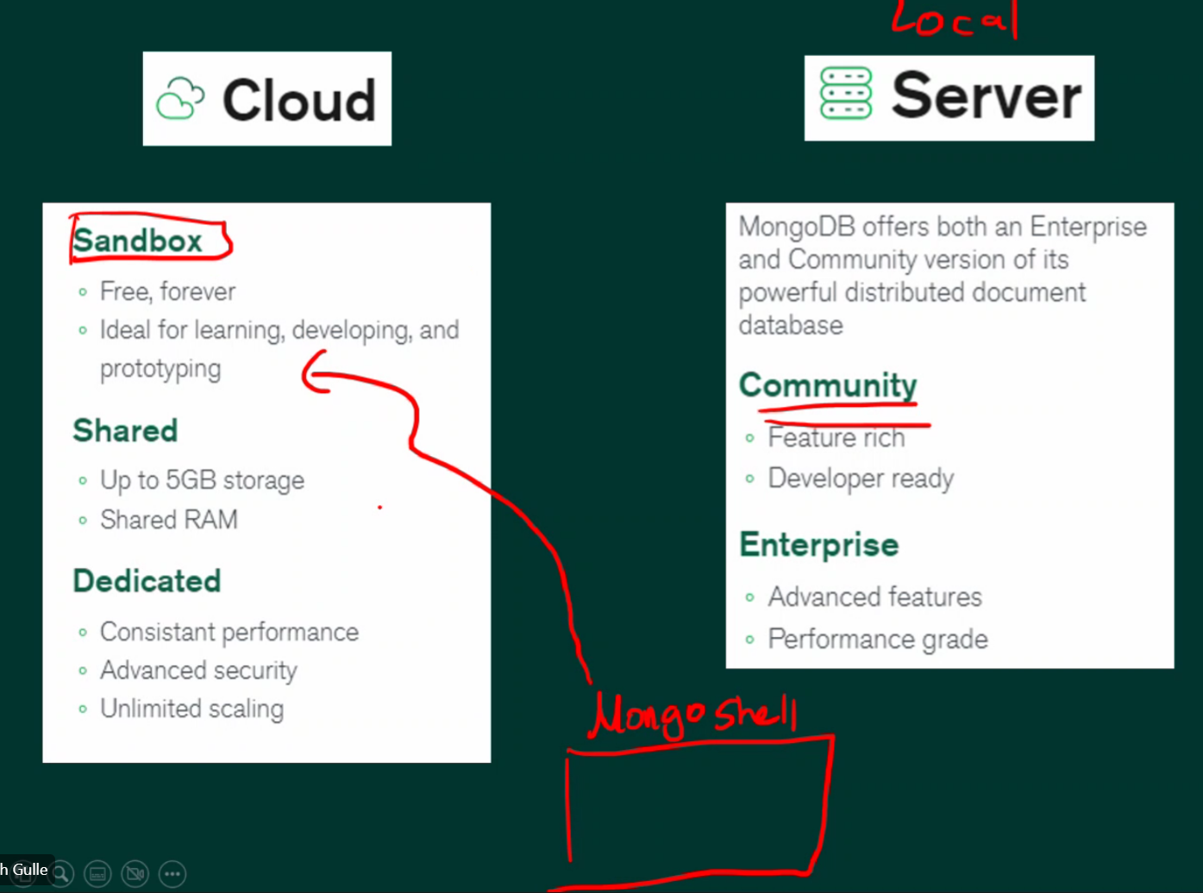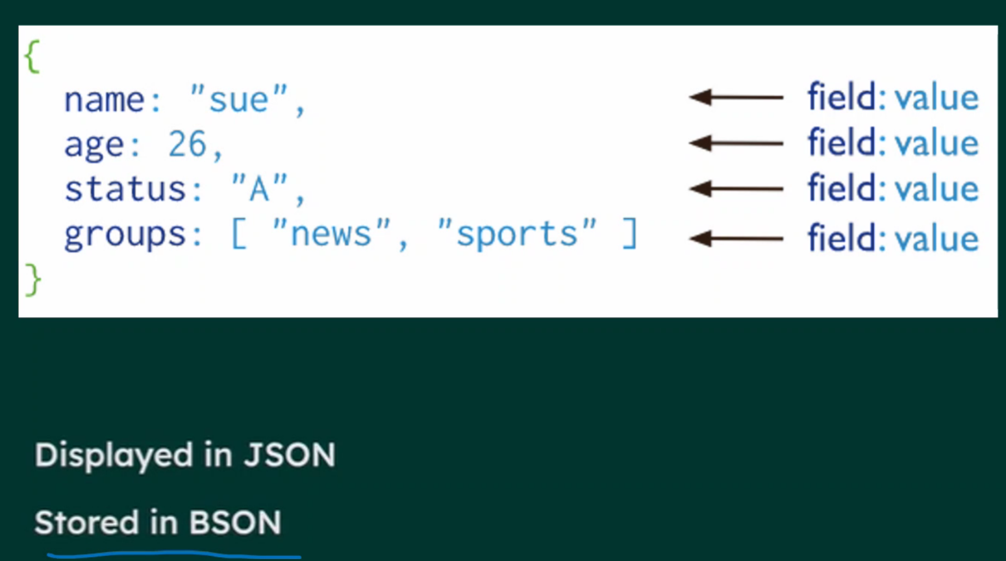

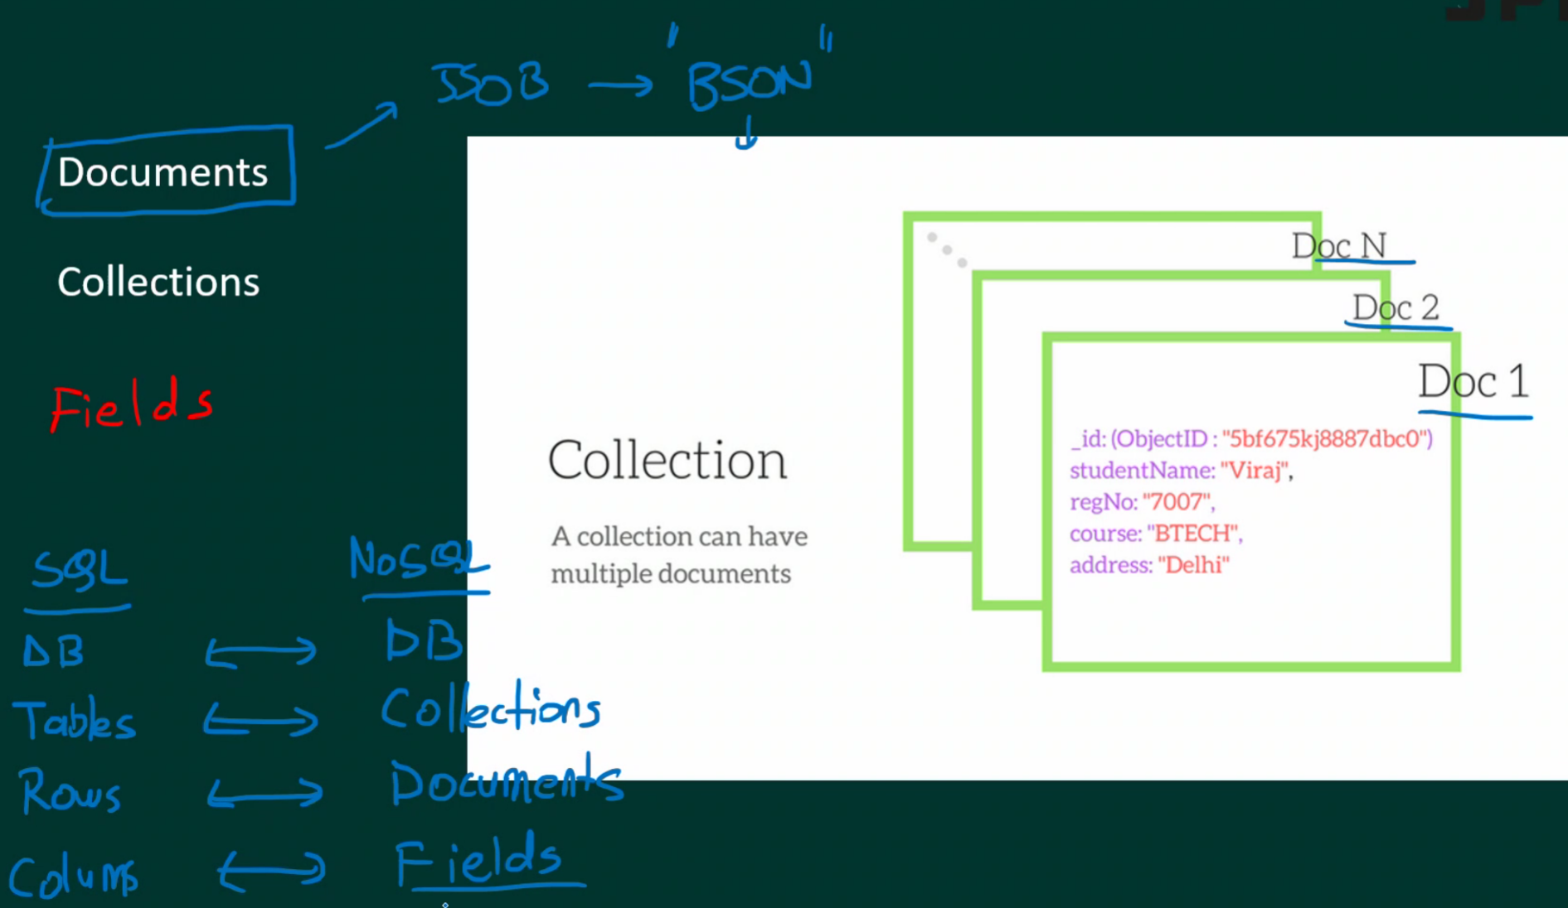

# Demo

Can use ‘mongosh’ in any shell/terminal to activate the mongo shell

db.<collection_name>.insertOne(<dict>) – insert one document

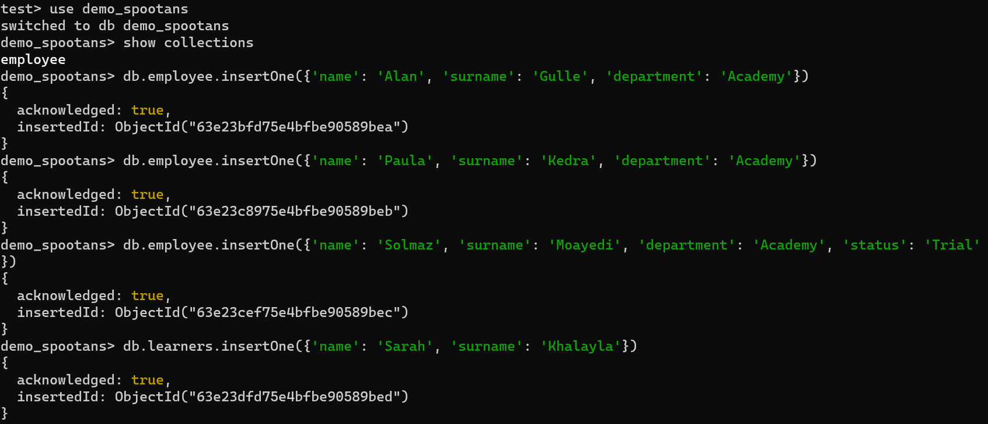

db.<collection_name>.insertMany([<dict1>, <dict2>]) – insert multiple documents

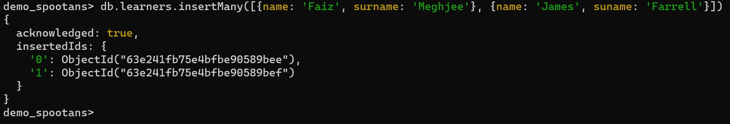

db.<collection_name>.find() – displays all data in the collection

db.employee.find({name:'Alan'}) – find a specific document

db.learners.find({name:{$in:['Sarah', 'Faiz']}}) – find multiple data based on condition

db.employee.findOne() – finds one document from the collection

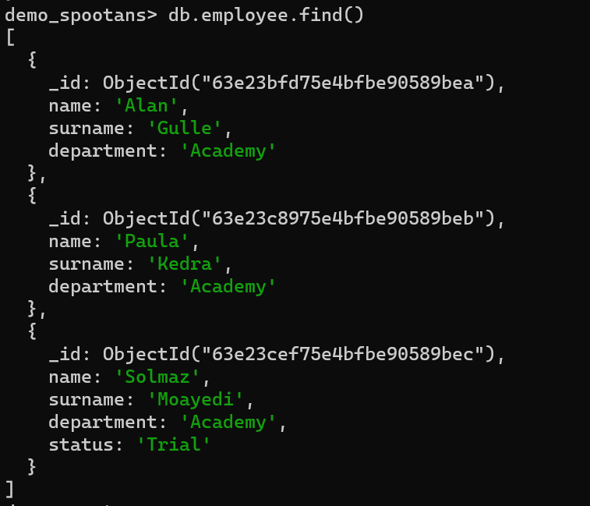

‘$’ dollar sign represents operator

‘gt’ is greater than

‘lt’ is less than

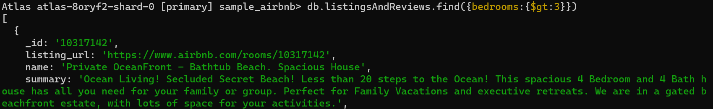

{$and:[{bedrooms:{$gt:8}},{beds:{$gte:16}}]}

$and: for multiple conditions to be met

$or: for either condition to be met

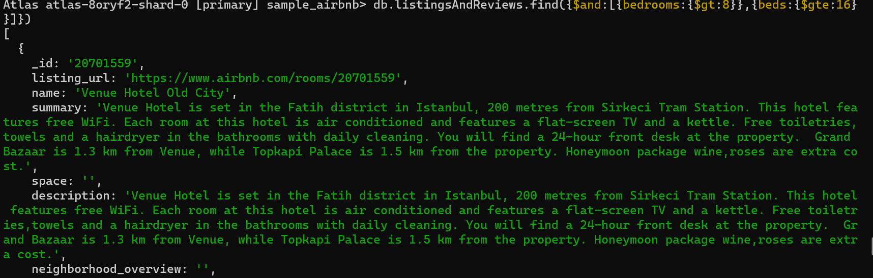

<https://www.mongodb.com/developer/products/mongodb/cheat-sheet/>